# Web 3 Practical

1. Using CSS transforms and transitions create the effect displayed the 1st half of the video demo provided
2. Using CSS keyframe animations create the effect displayed in the 2nd half of the video demo provided
3. Using the 960 framework transform the provided HTML file into the following output:

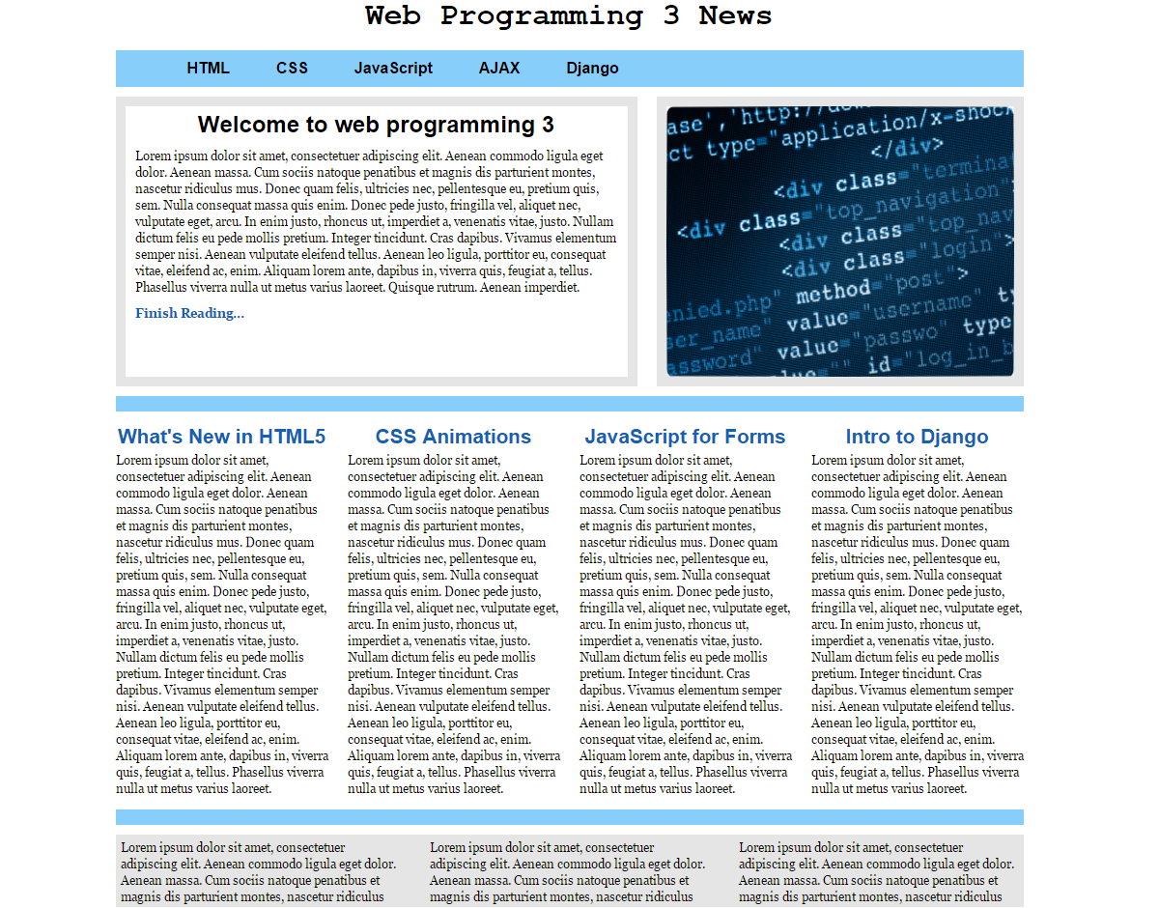

you can use a local 960 CSS framework file or a content delivery network for the 2nd exercise. Documentation about the 960 grid system can be found at: <http://960.gs/>

1. if you open the file p4.html in the browser you will see something similar to:

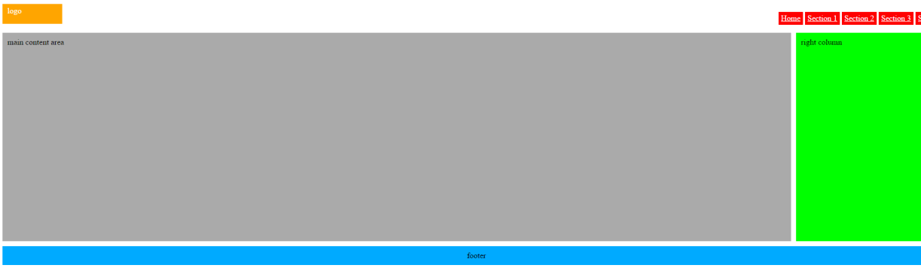

The objective of today’s practical is for you to modifiy the p4.css file in order to get the following look for a small screen size device:

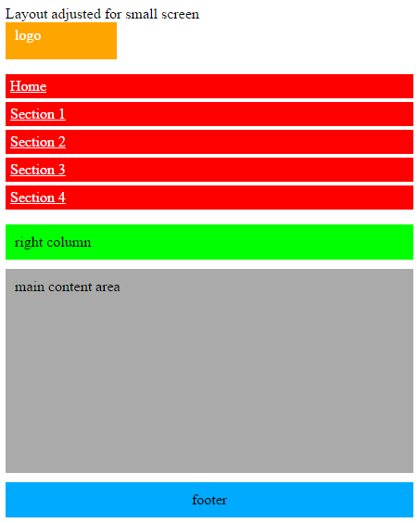

1. Install SASS in your computer and make sure it works by creating a .scss file with some variables on it and preprocessing it into a .css file.